**做题人：**陈志榕

**用时：**20分钟35秒

**生词：**

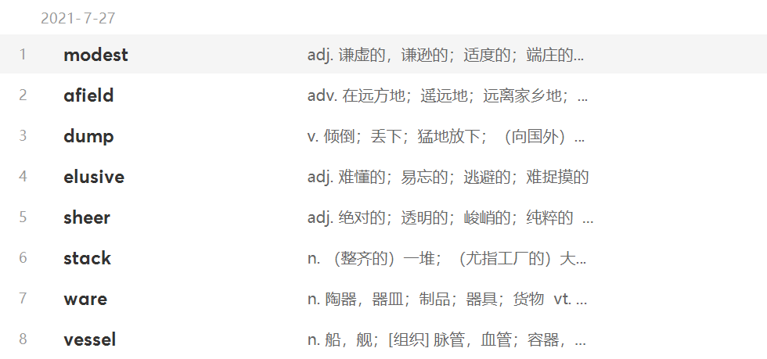

**词组：**

in large quantities 有着很大的数量

do justice to sth. 给……给予公正评价

be capable of doing 有能力做

**长难句分析：**

It has been estimated that Monte Testaccio contains the remains (of some 53 million amphorae, in which around 6,000million liters of oil were imported into the city from **overseas)**, imports into **imperial** Rome were supported by the full might of the **state** and were **therefore** quite exceptional----but the size (of the operations at Monte Testaccio), and the **productivity** and **complexity** (that **lay** behind them), **nonetheless** cannot fail to impress.

This **abundance** is **notable** in Roman settlements (especially **urban** sites) (where the labor that archaeologists have to put into the washing and sorting of potsherds (fragments of **pottery**) constitutes a high **proportion** of the total work during the **initial** phases of **excavation**.)

**错题分析：**

